**PROJECT BASED LAB REPORT**

**On**

**CAMPUS RECRUITMENT COMPANIES INFORMATION SYSTEM**

**Submitted in partial fulfilment of the**

**Requirements for the award of the Degree of**

**Bachelor of Technology**

**in**

**COMPUTER SCIENCE ENGINEERING**

**By**

**ROHINI PANDIRI 2100031934**



**DEPARTMENT OF COMPUTER SCIENCE ENGINEERING**

**K L University**

Green Fields, Vaddeswaram, Guntur District-522 502

**2021-2022**

**K L University**

**DEPARTMENT OF COMPUTER SCIENCE ENGINEERING**



***CERTIFICATE***

This is to certify that this project based lab report entitled **“CAMPUS RECRUITMENT COMPANIES INFORMATION SYSTEM”** is a bonafide work done by **ROHINI PANDIRI 2100031934** in partial fulfilment of the requirements for the award of degree in **BACHELOR OF TECHNOLOGY** in **COMPUTER SCIENCE ENGINEERING**  during the Academic year 2021-2022.

**Faculty in Charge**

Smt P.S.G.ARUNA SRI **Head of the Department**

Dr. V.SRIKANTH

**Project guide**

Smt P.S.G.ARUNA SRI

**K L University**

**DEPARTMENT OF COMPUTER SCIENCE ENGINEERING**



***DECLARATION***

We hereby declare that this project based lab report titled **“CAMPUS RECRUITMENT COMPANIES INFORMATION SYSTEM”** has been prepared by us in partial fulfilment of the requirements for the award of degree “**BACHELOR OF TECHNOLOGY in COMPUTER SCIENCE ENGNEERING**” during the Academic year 2021-2022.

We also declare that this project based lab report is of our own efforts and it has not been submitted to any other university for the award of any degree.

**ROHINI PANDIRI**

**2100031934**

**ACKNOWLEDGEMENT**

Our sincere thanks to **Smt P.S.G.ARUNA SRI** in the Lab for their outstanding support through out the project for the successful completion of the work.

We express our gratitude to **DR.V. SRIKANTH,** Head of the Department for Computer science and Engineering for providing us with adequate facilities, ways and means by which we are able to complete this project based Lab.

We would like to place on record the deep sense of gratitude to the honourable Vice Chancellor, K L University for providing the necessary facilities to carry the project based Lab.

Last, but not the least, we thank all Teaching and Non-Teaching Staff of our department and especially my classmates and my friends for their support in the completion of our project based Lab.

**ROHINI PANDIRI**

**2100031934**

**CONTENTS**

**s.no content**

**1. ABSTRACT**

**2. INTRODUCTION**

**3. FUNCTIONAL REQUIREMENTS**

**4. NON-FUNCTIONAL REQUIREMENTS**

**5. CODE**

**6. OUTPUT**

**7. ADVANTAGES & DISADVANTAGES**

**8. CONCLUSION**

**9. BIBLIOGRAPHY**

**ABSTRACT**:

The title of the project is to develop a program for campus recruitment company’s information system. Companies hire engineering graduates into roles that range from software application development, software or hardware testing, research, IT consulting, marketing , finance etc. . The campus recruitment procedure has become one of the most popular avenues to recruit students into companies. Most of the colleges offer the campus recruitment facilitate the recruitment through a special department known as the placement department.

A college campus recruitment system that consists of a student login, company login and an admin login. The project is beneficial for college students, various companies visiting the campus for recruitment and even the college placement officer. The software system allows the students to create their profiles and upload all their details including their marks onto the system. The admin can check each student details and can remove faulty accounts. The system also consists of a company login where various companies visiting the college can view a list of students in that college and also their respective resumes.

They show the least interest in this due to various factors viz., projects, assignments or more of activities loaded by the colleges as part of their curriculum thinking that it is not useful. It is the responsibility of the companies training on placement to make the students equipped on all aspects of career development along with creating a very good impact in them which makes them feel every minute they spend in the placement training session is worth being there and will help them in getting placed in their dream companies.

**INTRODUCTION**

|  |
| --- |
| A college campus recruitment system that consists of a student login, company login and an admin login. The project is beneficial for college students, various companies visiting the campus for recruitment and even the college placement officer. The software system allows the students to create their profiles and upload all their details including their marks onto the system. The admin can check each student details and can remove faulty accounts. The system also consists of a company login where various companies visiting the college can view a list of students in that college and also their respective resumes. The software system allows students to view a list of companies who have posted for vacancy. The admin has overall rights over the system and can moderate and delete any details not pertaining to college placement rules. The system handles student as well as company data and efficiently displays all this data to respective sides. The software system allows students to view a list of companies who have posted for vacancy. The admin has overall rights over the system and can moderate and delete any details not pertaining to college placement rules. The system handles student as well as company data and efficiently displays all this data to respective sides. The major objective of campus placement is to identify the talented and qualified professionals before they complete their education. This process reduces the time for an industry to pick the candidates according to their need. It is a cumbersome activity and hence majority of the companies find it difficult to trace the right talent. Many students do not understand the importance of placement training that is being imparted, whether it is an aptitude training or soft skills. |
|  |

**DESCRIPTION:**

The project is done based on java programming. This is through object oriented programming. “CAMPUS RECRUITMENT MANAGEMENT” is website developed for the company to facilitate the ease of application for internship or recruitment in the company. This website acts as a time saving means for both the company and the applicants in this large public sector undertaking. Thus, the required candidate can be called upon for the interview and selection process at the campus. The details entered and fetched at the time of filtering is crucial thus precise care has been taken while coding the way filtering works. The administrator has the privilege to modify the fields when the changes occur. Thus making it exceptionally ease at the administrators side to operate the site dynamically.

The database is used to facilitate lower number of entries in it. The selection and rejection is based on strict inspection of validity of application forms by panel of HR members at HMT, where the candidate shortlisted is summoned for interview on reports being generated after the specific search. The initial phases of the development included the complete analysis of the company’s working process, the way the applications are processed. Thus, the user side is designed from the approach of ease of application and mandatory fields as per the company, the administration side has been developed for HR persons in the company. The website is designed taking care of small process to be doing by theplacements.

Most colleges that offer campus recruitment facilitate the recruitment through a special department known as the placement department. The placement department is steered by a placement officer who oversees the entire recruitment process.

The various stages that are involved in a typical campus recruitment program are as follows:

* Pre-placement Talk
* Aptitude Test
* Group Discussion
* Technical Interview
* HR Interview

### Pre-Placement Talk

A presentation about the company will be made during the pre-placement talk. Basically, the presentation includes the information like selection procedure, company’s milestones, organizational achievements, candidate scope of improvement within the organization if selected, salary, employment benefits. Usually this presentation will end up with question and answer session, students given chance to ask questions about.

### Written Test

Qualified students will undergo a test. This is usually a simple aptitude test but depending on company and the position looking for, the difficulty level of the test may be at the higher side.

### Group discussion

Most of the companies will have this round as a filtering round. This round may be or may not be conducted.

A common topic is placed before the group and a formal discussion or knowledge sharing is expected by the judge. Purpose of this round is to check communication skills, etiquette of person, listening ability, convincing power, group leadership, leader or follower and many more thing are evaluated based on requirement or the particular intention of organisation or company. It is very important to keep yourself updated with latest news and discussion topics for appearing in GD round.

### Technical Interview

Based on outcome of above said process, students will further undergo a round called technical round. This round evaluates the technical ability of the student. In most of the cases this will be an individual round but it may be grouped with the formal interview.

### Formal interview

Final round of the selection process, where the student’s stability and his confidence level towards the particular work will be evaluated. The [interview](https://en.wikipedia.org/wiki/Interview) focuses on overall personality of the candidate. The more practical application knowledge a candidate has, the more chances of their selection increase. So, having worked on projects in the industry, internships in relevant companies and industry visits to brands in the same sector will enhance a candidate's chance of selection.

The job application process can be a nerve racking experience; one that may involve a great deal of preparation and stress. However, being able to interview through campus recruitment presents a unique opportunity that not everyone has the chance to experience. Rather than having to go out and pound the pavement, send endless emails, or have the voicemail messages you leave unreturned, getting a job through campus recruitment can have the recruiters coming to you. This opportunity however, is one that can be even more beneficial if you are properly prepared to take full advantage of it.

**1. Study**

Similar to a college exam, proper preparation can be key to your success in a campus recruitment interview. Understanding what a possible employer does, knowing the history and circumstances surrounding their company or organization, and having knowledge about the position for which you are applying can make a favourable impression upon those with whom you are interviewing.

**2. Test Yourself**

Before your all-important interview, you might take some time to test yourself and your interview acumen. Consider questions that you might be asked by your interviewers. If you don't have ideas as to what these questions might be, you might want to search for typical interview questions on the Internet. When you answer these questions, you might want to try answering them aloud to hear how your answers sound and practice proper phrasing and articulation.

**3. Prepare Your Own Questions**

Asking questions related to a particular job or company can show that you are interested and educated regarding the position for which you are interviewing and the company or organization you are interviewing with. Sitting there with a blank stare when asked if you have questions for the interviewer can be a sign that you are unprepared or uninterested.

**4. Remember the Little Things**

The little things can make a big difference in the overall impression you make upon your interviewers. Having items like a working pen, paper, extra resumes and cover letters, and similar items can prevent you having to ask to borrow them from the asking for questions.

**FUNCTIONAL REQUIREMENTS ::**

|  |  |  |  |
| --- | --- | --- | --- |
| 1 |  | Companies information |  |
|  |  | To search for the companies the user need | Here we will be creating the list of details of company showing Name of company, rounds they can be conducted and salaries etc. |
|  |  | Displays all facility details that company provided | This is used to maintain the details of the companies and the job details for the use. |
|  |  | To search job recruitment in the company | This is used to search particular companies details when user gives a particular search number of that company name. |
|  |  | To generate details | Here in generating reports we will be able to display all the details of companies and salaries with details in the form of files. |
| 2 |  | Main Module |  |
|  |  | To display System | After all modules were integrated through files we display the complete information. |
|  |  | To process menu | Here **Processing Menu** can be done through if else statements with all the modules that are present in the file. |
|  |  | Initializations | Here **Initializations** can be done to methods, variables as well as objects which are present in classes |
|  |  | To access | To provide easy access **we** informed everything to user which will able to access his details . we can be able to read the file and record of that file, and write that file where he can be able to do modifications for files that are present .. |

**Purpose**  
  The purpose of doing this project is to provide all the requirements for the Companies Information System. The user can search easily anything regarding the companies he want with moving here and there. This will make his time manageable and there will no waste of time in going out.

**NON-FUNCTIONAL REQUIREMENTS**

INTERFACE:

An interface is a reference type in Java. It is similar to class. It is a collection of abstract

methods. A class implements an interface, thereby inheriting the abstract methods of

the interface. Along with abstract methods, an interface may also contain constants, default

methods, static methods, and nested types.

INHERITANCE:

Inheritance in java is a mechanism in which one object acquires all the properties and

behaviors of parent object. The idea behind inheritance in java is that you can create new

classes that are built upon existing classes.

ABSTRACT CLASS:

A class that is declared with abstract keyword, is known as abstract class in java. It can have abstract and non-abstract methods (method with body). **Abstraction** is a process of hiding the implementation details and showing only functionality to the user. Another way, it shows only important things to the user and hides the internal details for example sending sms, you just type the text and send the message. You don't know the internal processing about the message delivery.

ABSTRACT METHOD:

An abstract method is a method that is declared, but contains no implementation. Abstract classes may not be instantiated, and require subclasses to provide implementations for the abstract methods. Let's look at an example of an **abstract** class, and an abstract method.

STATIC KEYWORD:

All instances share the same copy of the variable. A class variable can be accessed directly with the class, without the need to create a instance.

FINALKEYWORD :

In the **Java** programming language, the **final keyword** is used in several different contexts to define an entity that can only be assigned once. Once a **final** variable has been assigned, it always contains the same value.

METHOD OVERRIDING:

In object oriented programming, is a language feature that allows a subclass or child class to provide a specific implementation of a method that is already provided by one of its super classes or parent classes.

ARRAYS:

Java provides a data structure, the array, which stores a fixed-size sequential collection of elements of the same type. An array is used to store a collection of data, but it is often more useful to think of an array as a collection of variables of the same type

EXCEPTION HANDLING:

An exception (or exceptional event) is a problem that arises during the execution of a program. When an Exception occurs the normal flow of the program is disrupted and the program/Application terminates abnormally, which is not recommended, therefore, these exceptions are to be handled.

**CODE:**

import java.io. *;

import java.util.*;

class WriteFile88

{

int id;

String name;

double cgpa;

WriteFile88(String s, double cg)

{

name=s;

cgpa=cg;

}

}

class WriteFile66 extends WriteFile88

{

int id;

WriteFile66(int i, String s, double cg)

{

super (s, cg);

id=i;

}

void display ()

{

System.out.println("\n"+"WELCOME TO CAMPUS PLACEMENTS INFORMATION SYSTEM"+"\n");

}

}

public class WriteFile77

{

public static void main(String args[])

{

Scanner in =new Scanner(System.in);

System.out.println("Enter ID Number");

int iz=in.nextInt();

System.out.println("Enter Your Name");

String nm=in.next();

System.out.println("Enter your CGPA");

double cp=in. nextDouble();

WriteFile66 w = new WriteFile66(iz,nm,cp);

w.display();

try

{

PrintWriter pw = new PrintWriter("Myfile122.txt");

pw.print(w.id+"\t");

pw.print(w.name+"\t");

pw.print(w.cgpa+"\t");

pw.println();

pw. close();

}

catch (FileNotFoundException e)

{

System.out.println(e.getMessage());

}

int i=1;

do

{

try

{

PrintWriter cd=new PrintWriter("Myfile123.txt");

if(w.cgpa>=7.5)

{

System.out.println("CONGRATULATIONS"+"\t"+"Your are eligible for Placements");

System.out.println("The Company's List are:");

System.out.println("1.TCS"+"\n"+"2.WIPRO"+"\n"+"3.HTC"+"\n"+"4.AIRTEL"+"\n"+"5.INFOSYS");

System.out.println("Enter your choice");

int choice =in.nextInt();

switch(choice)

{

case 1:

if(w.cgpa>=9)

{

cd.println("Welcome to TCS---Tata Consultancy Services");

cd.println("you have 3 rounds they are ");

cd.println("1.GROUP DISCUSSION "+"\t"+"2.HR ROUND"+"\t"+"3. INTERVIEW");

cd.println("the salary is 3.3lakh/annum");

cd.close();

}

else

{

cd.println("Welcome to TCS--Tata Consultancy Services");

cd.println("you have 6 rounds they are ");

cd.println("1.APTITUDE TEST"+"\t"+"2.MOCK TEST"+"\t"+"3.GROUP DISCUSSION"+"\t"+"4.HR ROUND"+"\t"+"5.MAGAGERIAL INTERVIEW"+"\t"+"6.TECHNICAL INTERVIEW"+"\t");

cd.println("the salary is 3.2 lakh/annum");

cd.close();

}

break;

case 2:

if(w.cgpa>=9)

{

cd.println ("Welcome to WIPRO: Western India Products ");

cd.println ("you have 3 rounds they are ");

cd.println ("1. GROUP DISCUSSION "+"\t"+"2.HR ROUND"+"\t"+"3. INTERVIEW");

cd.println ("the salary is 3.3lakh/annum");

cd.close ();

}

else

{

cd.println ("Welcome to WIPRO: Western India Products");

cd.println ("you have 5 rounds they are ");

cd.println ("1. APTITUDE TEST"+"\t"+"2. MOCK TEST"+"\t"+"3.GROUP DISCUSSION"+"\t"+"4.HR ROUND"+"\t"+"5.TECHNICAL INTERVIEW"+"\t");

cd.println ("the salary is 3 lakh/annum");

cd.close ();

}

break;

case 3:

if(w.cgpa >=9)

{

cd.println ("Welcome to HTC");

cd.println ("you have 4 rounds they are ");

cd.println ("1. GROUP DISCUSSION "+"\t"+"2. SEMINARS"+"\t"+"3.HR ROUND"+"\t"+"4. INTERVIEW");

cd.println ("the salary is 3.8lakh/annum");

cd.close ();

}

else

{

cd.println ("Welcome to HTC");

cd.println ("you have 7 rounds they are ");

cd.println ("1. APTITUDE TEST"+"\t"+"2. MOCK TEST"+"\t"+"3. SEMINARS"+"\t"+",4. GROUP DISCUSSION"+"\t"+"5.HR ROUND"+"\t"+"6. MAGAGERIAL INTERVIEW"+"\t"+"7.TECHNICAL INTERVIEW"+"\t");

cd.println ("the salary is 3.6 lakh/annum");

cd.close ();

}

break;

case 4:

if (w.cgpa >=9)

{

cd.println ("Welcome to AIRTEL");

cd.println ("you have 4 rounds they are ");

cd.println ("1. GROUP DISCUSSION "+"\t"+"2.HR ROUND"+"\t"+"3. MAGAGERIAL INTERVIEW"+"\t"+"4. TECHNICAL INTERVIEW");

cd.println ("the salary is 4lakh/annum");

cd.close ();

}

else

{

cd.println ("Welcome to AIRTEL"+"\n");

cd.println ("you have 7 rounds they are "+"\n");

cd.println ("1. APTITUDE TEST"+"\t"+"2. MOCK TEST"+"\t"+"3. SEMINARS"+"\t"+",4. GROUP DISCUSSION"+"\t"+"5.HR ROUND"+"\t"+"6. MAGAGERIAL INTERVIEW"+"\t"+"7. TECHNICAL INTERVIEW"+"\t");

cd.println ("the salary is 3.6 lakh/annum");

cd.close ();

}

break;

case 5:

if(w.cgpa >=9)

{

cd.println ("Welcome to Infosys "+"\n")

cd.println ("you have 3 rounds they are "+"\n");

cd.println ("1. GROUP DISCUSSION "+"\t"+"2.HR ROUND"+"\t"+"3. INTERVIEW");

cd.println ("the salary is 3.3lakh/annum"+"\n");

cd.close ();

}

else

{

cd.println ("Welcome to INFOSYS"+"\n");

cd.println ("you have 6 rounds they are "+"\n");

cd.println ("1. APTITUDE TEST"+"\t"+"2. MOCK TEST"+"\t"+"3. SEMINARS"+"\t"+",4. GROUP DISCUSSION"+"\t"+"5.HR ROUND"+"\t"+"7.TECHNICAL INTERVIEW"+"\t");

cd.println ("the salary is 3 lakh/annum");

cd.close ();

}

break;

default:

System.out.println("please enter correct option"); break;

}

}

else

{

System.out.println("your are not eligible for placements");

}

}

catch(FileNotFoundException e)

{

System.out.print(e.getMessage());

}

try

{

Scanner s=new Scanner(new BufferedReader(new FileReader("Myfile122.txt")));

System.out.println();

while(s.hasNext())

{

System.out.print(s.next()+"\t");

}

System.out.println();

}

catch(FileNotFoundException e1)

{

System.out.print(e1.getMessage());

}

try

{

Scanner sc=new Scanner (new BufferedReader(new FileReader("Myfile123.txt")));

System.out.println();

while(sc.hasNext())

{

System.out.print(sc.next() +" ");

}

}

catch(FileNotFoundException e2)

{

System.out.print(e2.getMessage());

}

System.out.println("\n"+" ");

System.out.println("TO Continue or To know other Company Details Enter any number Except 10 and to exit Enter Number 10 ");

i=in.nextInt();

} while(i!=10);

}

}

**OUTPUT:**

**SCREEN SHOTS:**

**Output-1**

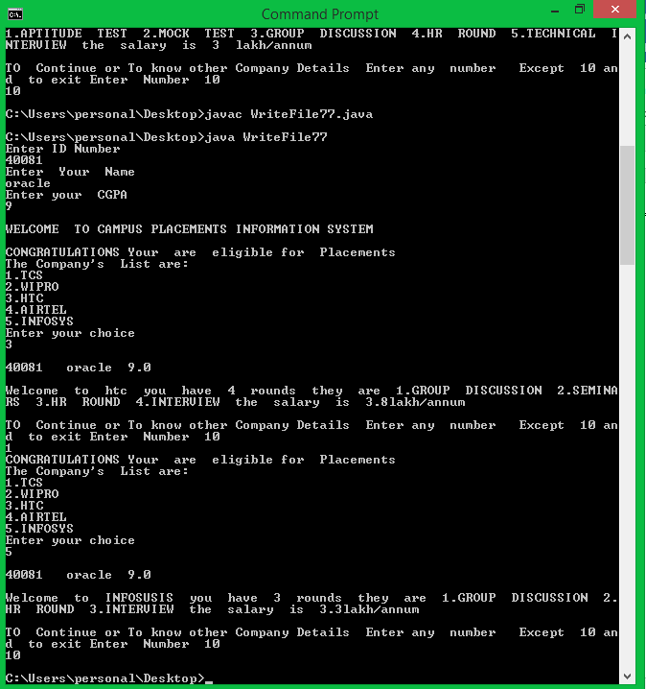

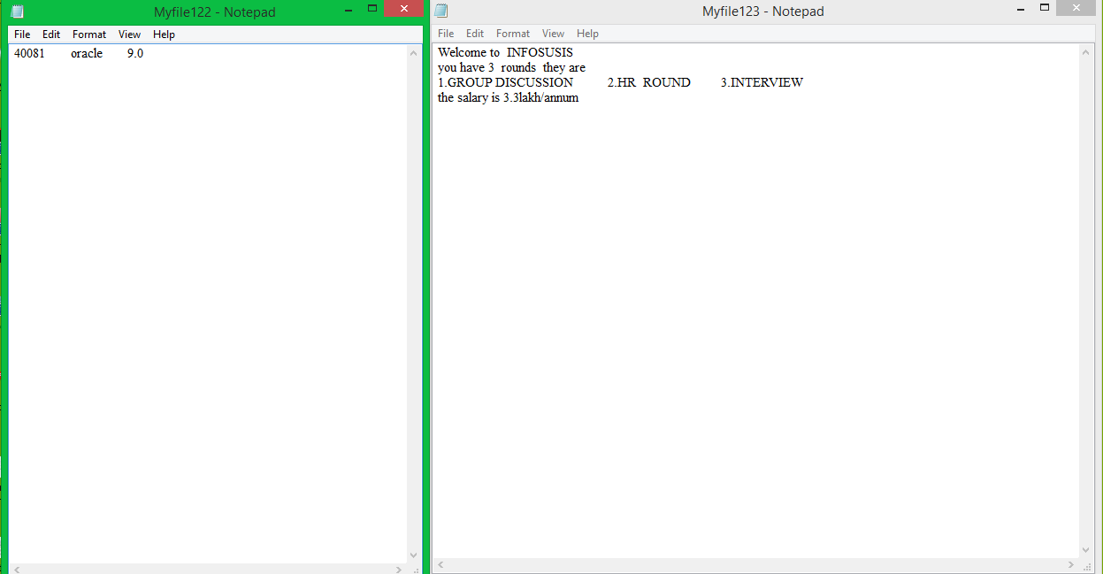

**Output-2**

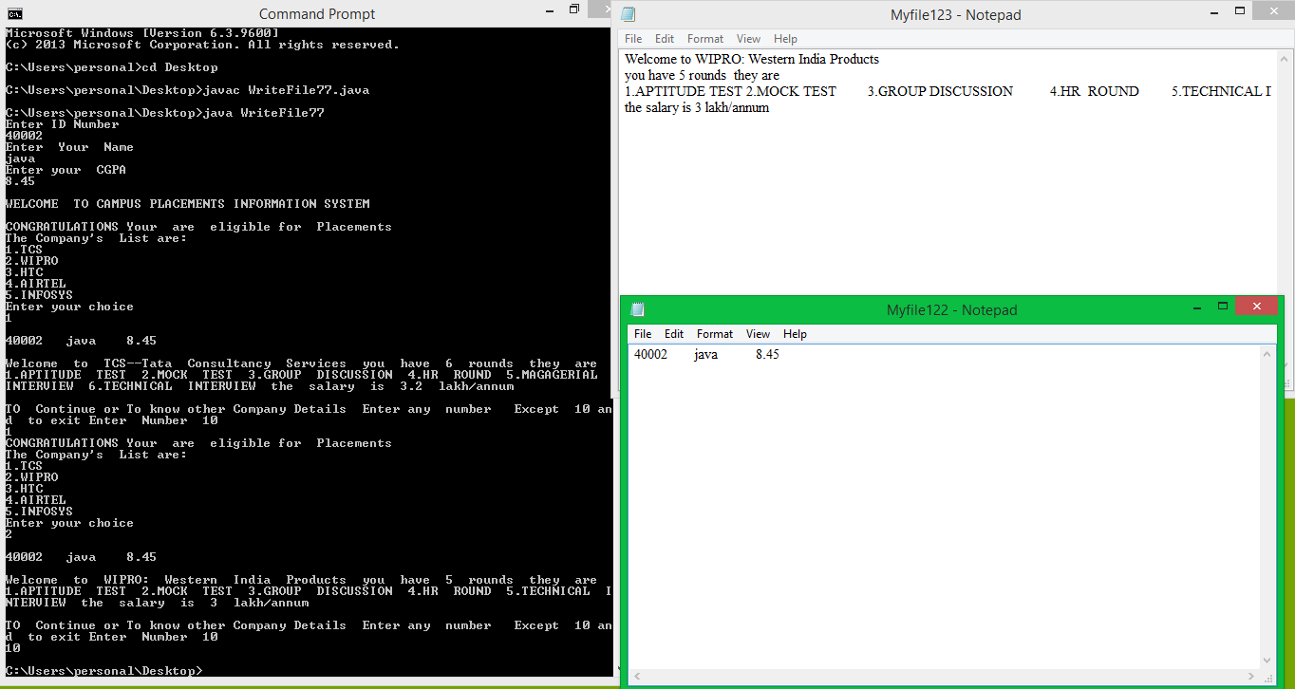

**ADVANTAGES:**

* There will be no need of putting up notice or emailing every student about the company coming in college. The students can keep updated themselves through this software.
* The company can view all students detail and system can shortlist students according to their criteria instead of doing manually.
* There is admin login can view and manage both students and companies account and also can put up notifications.
* Student can register online instead of going to placement department for registration.
* This system saves time and efforts.

**DISADVANTAGES**:

* Student can’t edit their application once sent. It would require admin to change the data.
* It requires large database.

**CONCLUSION:**

“Campus recruitment companies information system” allows the creation of an application specification regarding recruitment information related to the applicant . This website has been designed as a sub site for a major site in the pipeline. It deals with the recruitment related aspects of the company. Using the portal, the customers will also be facilitated with quotations of the heavy machineries manufactured by the companies at the campus. The recruitment and internship process will be a automated affair after the site is being implemented.

The project can be used to identify an applicant in the organization. The database would maintain the complete details of the applicant. Each applicant will be assigned a specific applicant number.

**BIBLIOGRAPHY:**

1. Herbert Schildt, “The Complete Reference Java2”, 5th edition TMH, 2002.
2. Timothy A. Budd, “An Introduction to Object-Oriented Programming”, 3/E, Pearson, 2008.
3. Jim Keogh, “The Complete Reference J2EE”, TMH, 2006.
4. Deitel&Deitel, “‘JAVA – How to program”, 6th edition, PHI, 2007.